**Lesson 05 Lesson-End Project**

**Customizing EC2 Instance for Web Instance**

**Project agenda:** To create a VPC and launch a web instance

**Description:** You are required to create a custom VPC and a subnet and attach the subnet to the VPC. Additionally, create an internet gateway and route table, and launch an EC2 instance.

**Tools required:** AWS Management Console

**Prerequisites:** AWS account

**Expected deliverables:** EC2 web instance

Steps to be followed:

1. Create a custom VPC and enable DNS hostname
2. Create an internet gateway and attach it to the VPC
3. Create a subnet and a route table
4. Configure a route table
5. Launch the EC2 instance

**Step 1: Create a custom VPC and enable DNS hostname**

1. Open the AWS Management Console and search for **VPC**

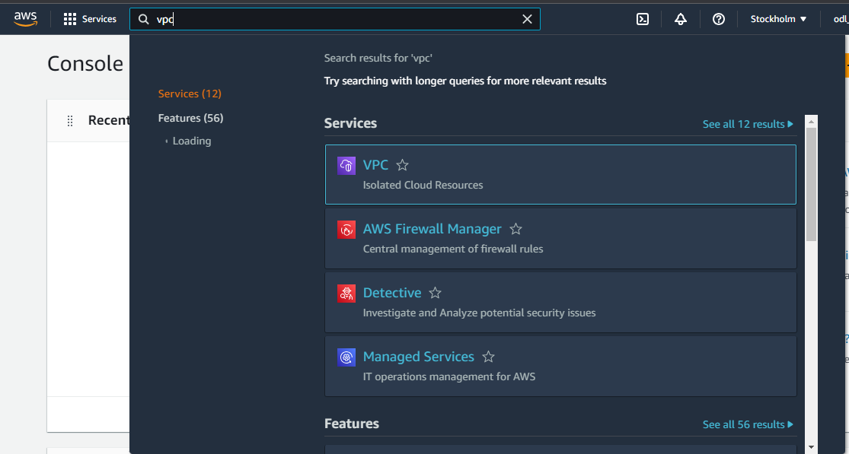

1. Clickon **Create VPC**

1. Enter **my-custom-VPC** as the VPC Name and **10.0.0.0/16** as the IPv4 CIDR

1. Click on **Create VPC**

The VPC has been created successfully.

1. Now, click on **Edit VPC settings** under **Actions**

1. Select **Enable DNS hostnames** under **DNS settings**, and thenclick on **Save**

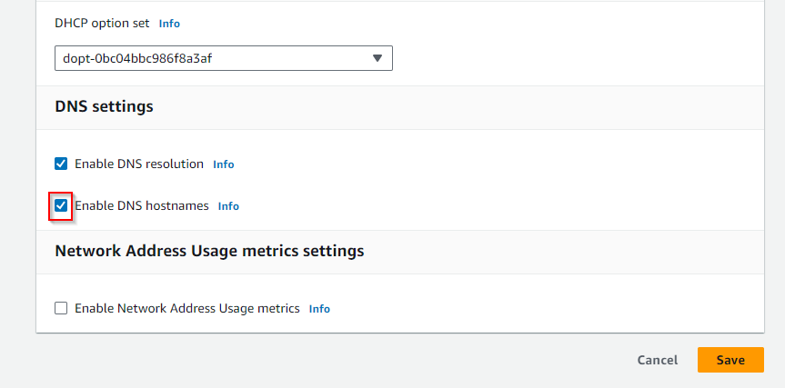

DNS has been successfully enabled.

**Step 2: Create an internet gateway and attach it to the VPC**

1. Navigate to the **Internet gateways** page

1. Click on **Create internet gateway**

1. Enter the name **my-custom-gateway** and click on **Create internet gateway**

1. Click on **Attach to VPC** under **Actions**

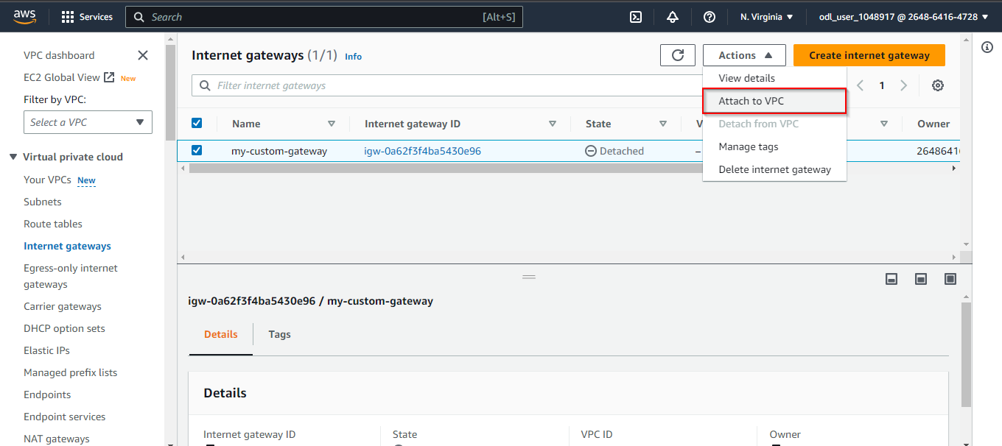

1. Select **my-custom-VPC** and click on **Attach internet gateway**

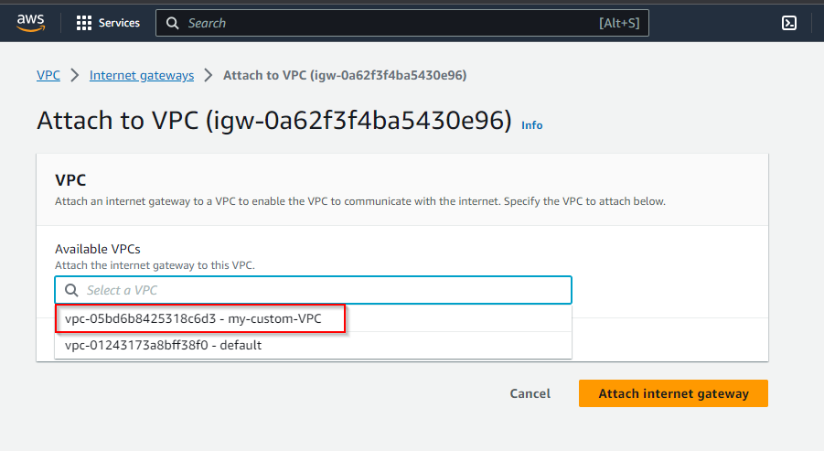

The Internet gateway has been attached successfully.

**Step 3: Create a subnet and a route table**

1. Navigate to **Subnets** and click on **Create** **Subnet**

1. Choose **my-custom-VPC** and click on **Create subnet**

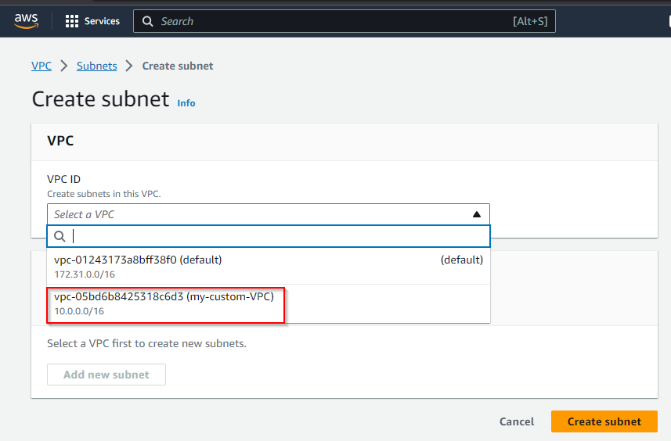

1. Enter **my-subnet-custom** as the **Subnet name**, choose the **Availability Zone**, set **10.0.0.0/16** as the IPv4 CIDR block, and click on **Create subnet**

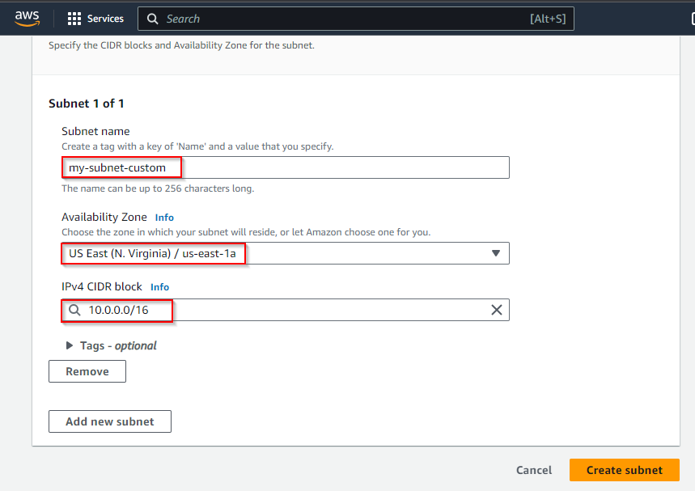

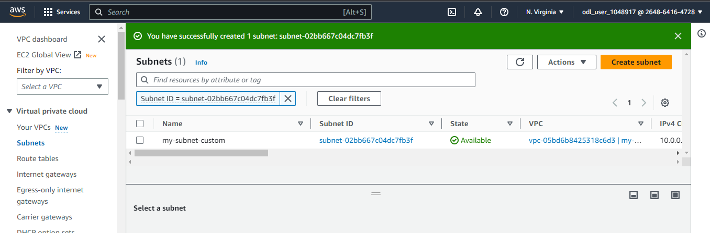

The subnet has been created successfully.

1. Select the subnet, click on **Actions**, and choose **Edit subnet settings**

1. Choose the **Enable auto-assign public IPv4 addresses** checkbox and **Save** the settings

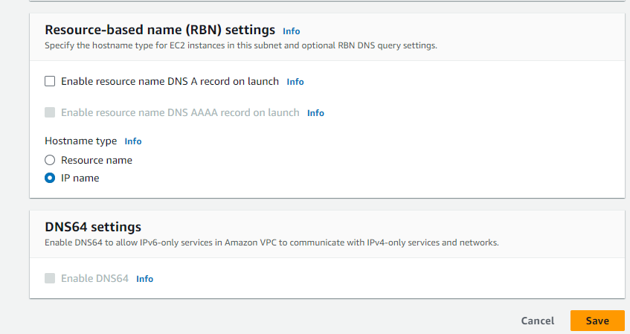

1. Navigate to the **Route tables** page and click on **Create route table**

1. Enter **my-custom-route** as the name, select **my-custom-VPC** in the VPC field, and create the route table

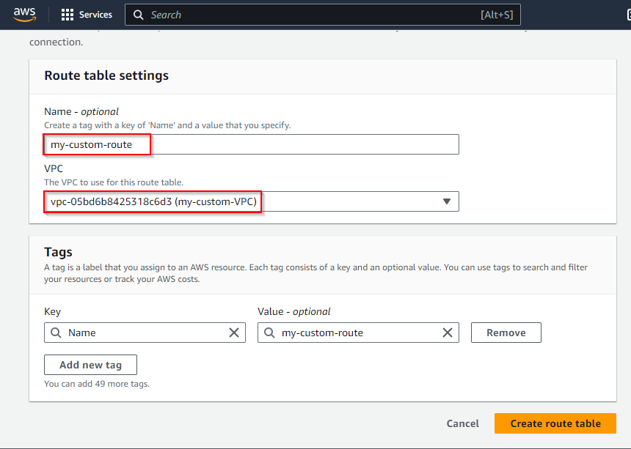

1. Select the route table, click on **Actions**, and choose **Edit routes**

1. Click on **Add route**

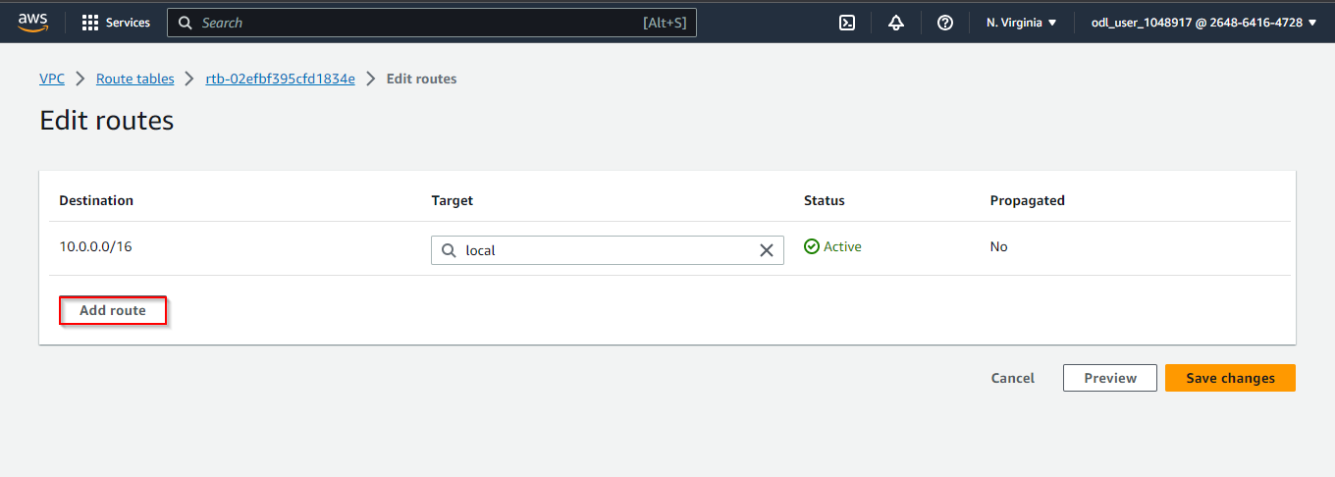

1. Select **Internet Gateway** in the **Target** field

1. Click on **Save changes**

The edit route table has been successfully created.

**Step 4: Configure a route table**

1. In the **Route tables** dashboard, click on **Edit edge associations** under **Actions**

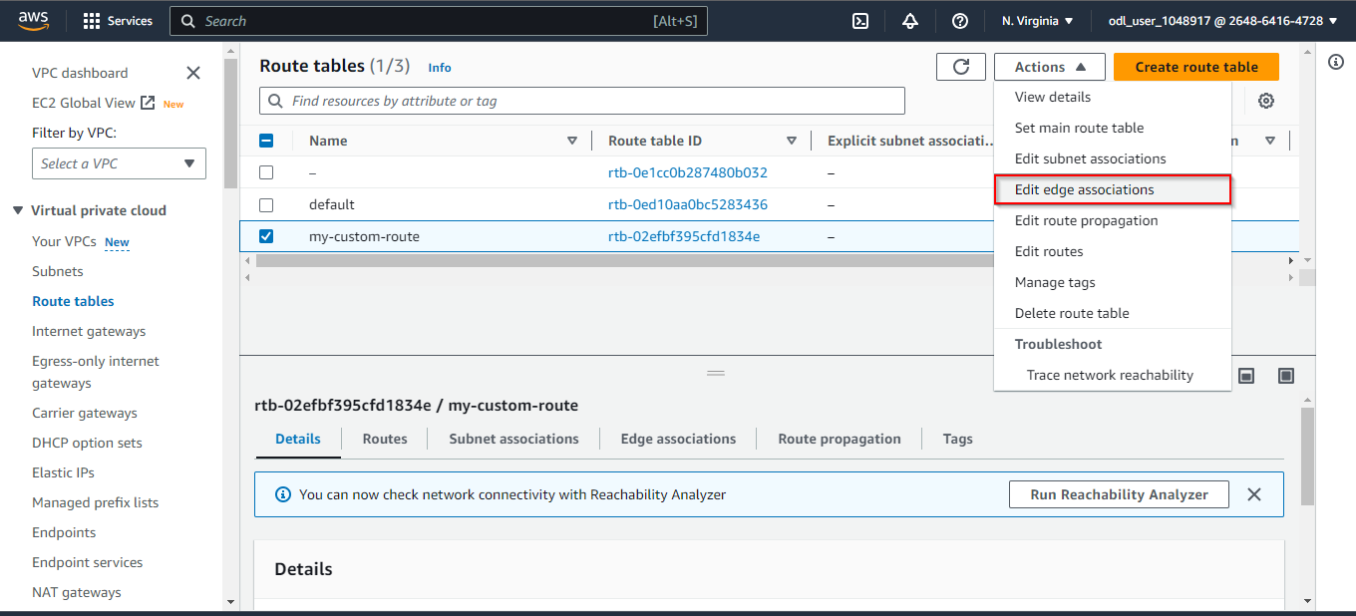

1. Select **my-subnet-custom** and click on **Save associations**

**Step 5:** **Launch the EC2 instance**

1. Navigate to the EC2 console and click on **Instances**

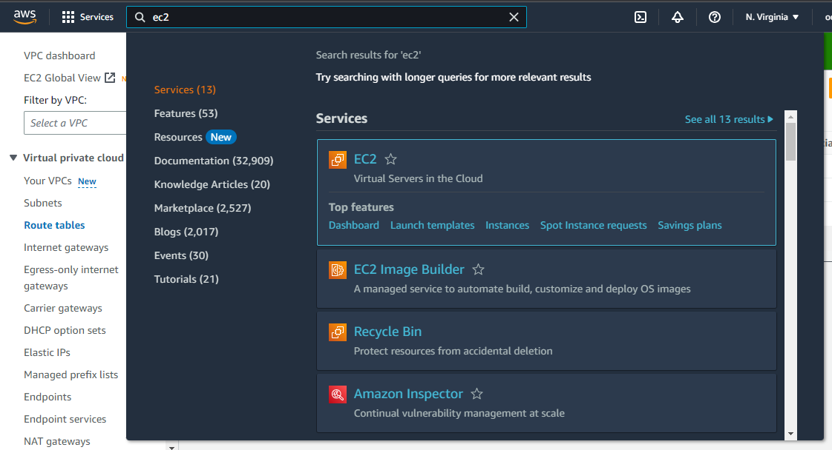

1. Click on **Launch instances**

1. Enter the name **my-custom-web** in the field

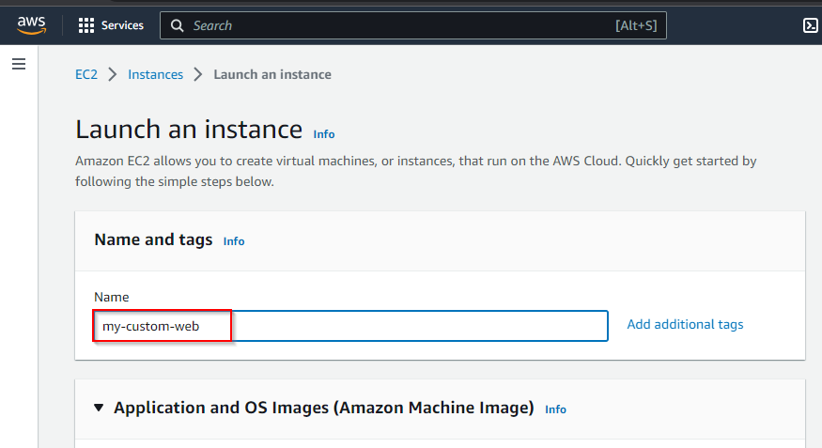

1. Click on the **Amazon Linux** optionand select the **SSD Volume** **Type** as **AMI**

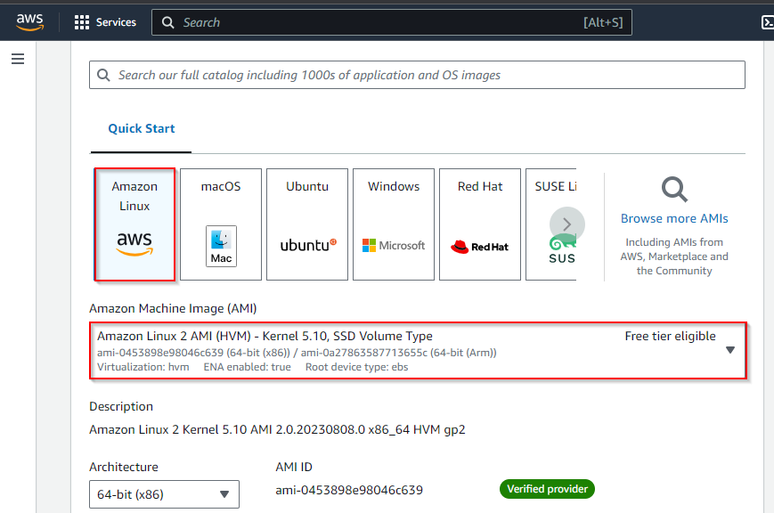

1. Select the instance type, such as **t2.micro**

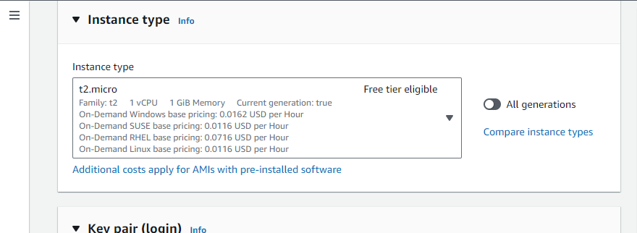

1. Enter the **Key pair name** and click on the **Create key pair** button

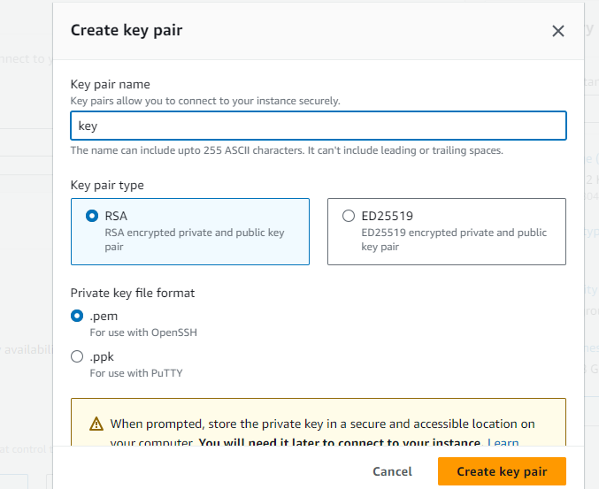

1. Configure **Network settings** by selecting your VPC and an availability zone

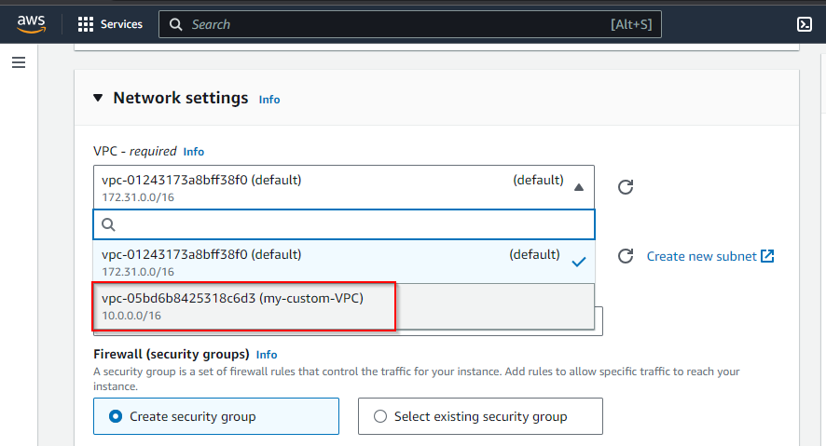

1. Select the **availability zone** in the **Subnet**

1. Add inbound rules for **HTTP** and **HTTPS**

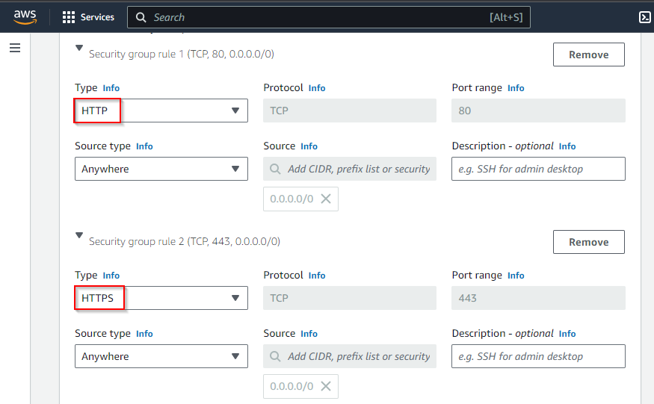

1. Click on **Advanced details,** enter the code in **User data,** and click on **Launch instance**

**#!/bin/bash**

**yum update -y**

**yum install httpd -y**

**cd /var/www/html**

**echo "LAUNCH MINI WEBSITE" > index.html**

**service httpd start**

1. After the instance is running, copy the IPv4 address and paste it into a browser to view

the mini website

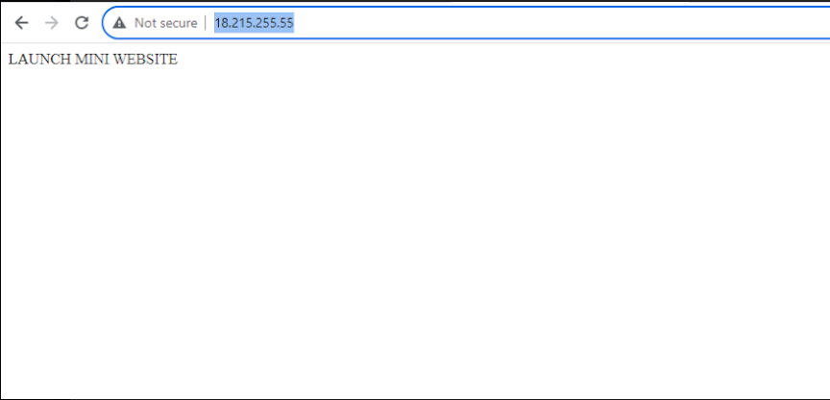

By following these steps, you have successfully customized an EC2 instance for web deployment within an Amazon Web Services (AWS) environment.